**Selenium Grid** allows us to execute multiple instances of WebDriver or Selenium **Remote Control** tests in parallel which uses the same code base, hence the code need NOT be present on the system they execute. The selenium-server-standalone package includes Hub, WebDriver, and Selenium RC to execute the scripts in grid.

Selenium Grid has a Hub and a Node.

* **Hub** - The hub can also be understood as a server which acts as the central point where the tests would be triggered. A Selenium Grid has only one Hub and it is launched on a single machine once.
* **Node** - Nodes are the Selenium instances that are attached to the Hub which execute the tests. There can be one or more nodes in a grid which can be of any OS and can contain any of the Selenium supported browsers.

**Architecture**

The following diagram shows the architecture of Selenium Grid.

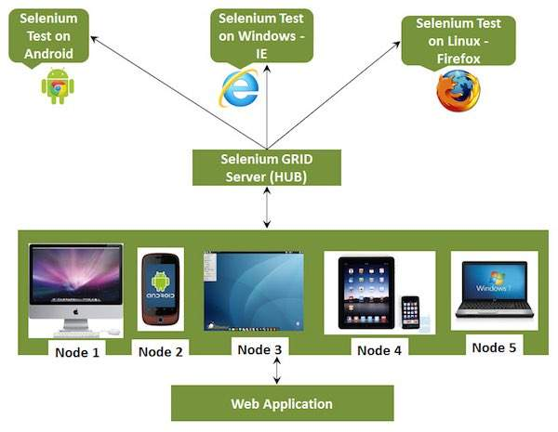

## Working with Grid

In order to work with the Grid, we need to follow certain protocols. Listen below are the major steps involved in this process:

* Configuring the Hub
* Configuring the Nodes
* Develop the Script and Prepare the XML File / webdriver
* Test Execution / webdriver
* Result Analysis / report

### Configuring the Hub

**Step 1** : Download the latest Selenium Server standalone JAR file from http://docs.seleniumhq.org/download/. Download it by clicking on the version as shown below.

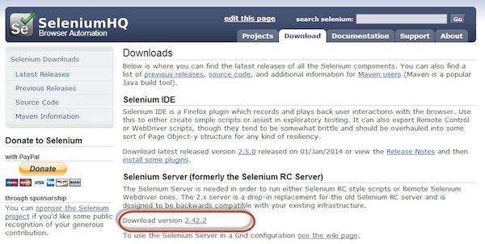

**Step 2** : Start the Hub by launching the Selenium Server using the following command. Now we will use the port '4444' to start the hub.

Note : Ensure that there are no other applications that are running on port# 4444.

java -jar selenium-server-standalone-2.25.0.jar -port 4444 -role hub -nodeTimeout 1000

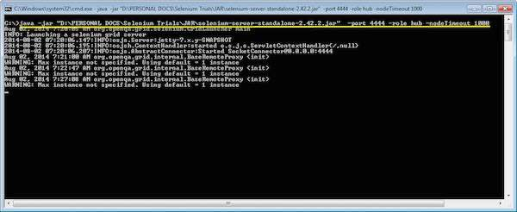

**Step 3** : Now open the browser and navigate to the URL http//localhost:4444 from the Hub (The system where you have executed Step#2).

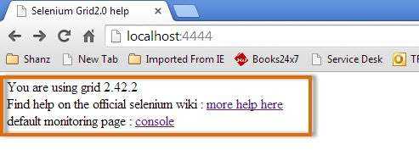

**Step 4** : Now click on the 'console' link and click 'view config'. The config of the hub would be displayed as follows. As of now, we haven't got any nodes, hence we will not be able to see the details.

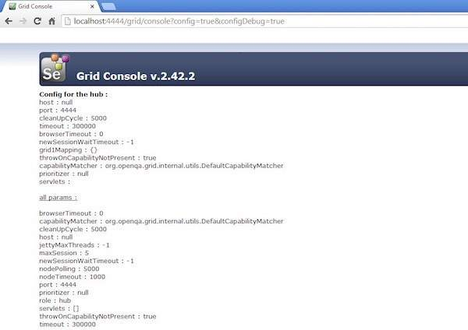

### Configuring the Nodes

**Step 1** : Logon to the node (where you would like to execute the scripts) and place the 'selenium-server-standalone-2.42.2' in a folder. We need to point to the selenium-server-standalone JAR while launching the nodes.

**Step 2** : Launch FireFox Node using the following below command.

java -jar selenium-server-standalone-2.42.2.jar -role node -hub http://10.30.217.157:4444/grid/register -browser browserName=firefox -port 5555

Where,

D:\JAR\selenium-server-standalone-2.42.2.jar = Location of the Selenium Server Standalone Jar File(on the Node Machine)

http://10.30.217.157:4444 = IP Address of the Hub and 4444 is the port of the Hub

browserName = firefox (Parameter to specify the Browser name on Nodes)

5555 = Port on which Firefox Node would be up and running.

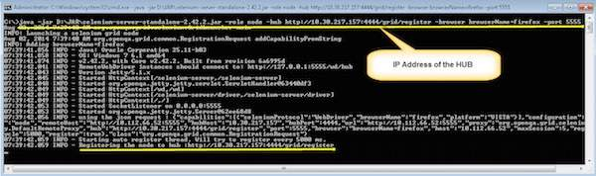

**Step 3** : After executing the command, come back to the Hub. Navigate to the URL - http://10.30.217.157:4444 and the Hub would now display the node attached to it.

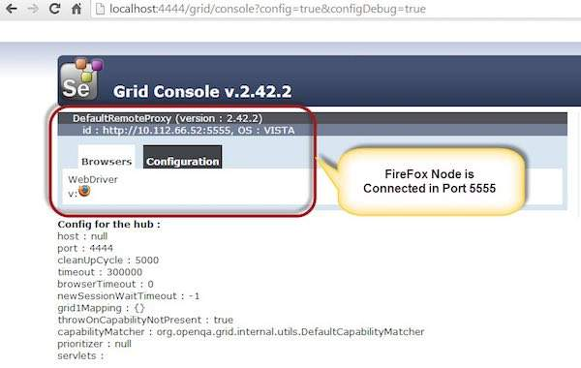

**Step 4** : Now let us launch the Internet Explorer Node. For launching the IE Node, we need to have the Internet Explorer driver downloaded on the node machine.

**Step 5** : To download the Internet Explorer driver, navigate to http://docs.seleniumhq.org/download/ and download the appropriate file based on the architecture of your OS. After you have downloaded, unzip the exe file and place in it a folder which has to be referred while launching IE nodes.

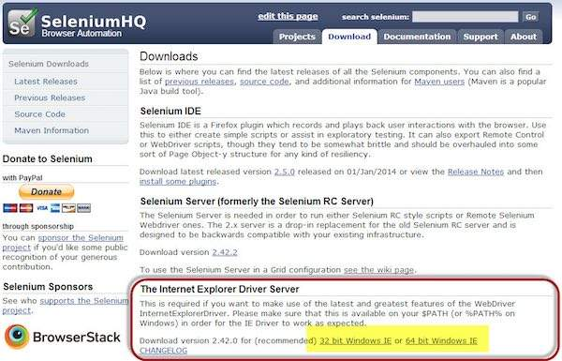

**Step 6** : Launch IE using the following command.

C:\>java -Dwebdriver.ie.driver=D:\IEDriverServer.exe -jar D:\JAR\selenium-server-standalone-2.42.2.jar -role webdriver -hub http://10.30.217.157:4444/grid/register -browser browserName=ie,platform=WINDOWS -port 5558

Where,

D:\IEDriverServer.exe = The location of the downloaded the IE Driver(on the Node Machine)

D:\JAR\selenium-server-standalone-2.42.2.jar = Location of the Selenium Server Standalone Jar File(on the Node Machine)

http://10.30.217.157:4444 = IP Address of the Hub and 4444 is the port of the Hub

browserName = ie (Parameter to specify the Browser name on Nodes)

5558 = Port on which IE Node would be up and running.

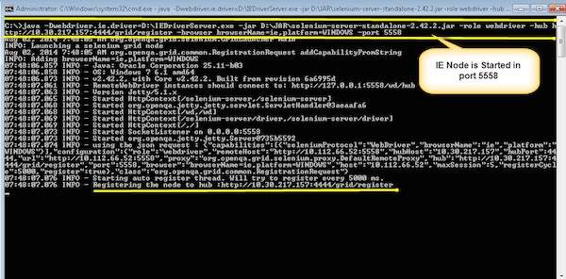

**Step 7** : After executing the command, come back to the Hub. Navigate to the URL - http://10.30.217.157:4444 and the Hub would now display the IE node attached to it.

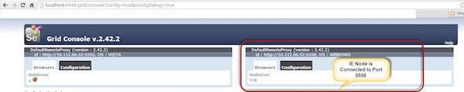

**Step 8** : Let us now launch Chrome Node. For launching the Chrome Node, we need to have the Chrome driver downloaded on the node machine.

**Step 9** : To download the Chrome Driver, navigate to http://docs.seleniumhq.org/download/ and then navigate to Third Party Browser Drivers area and click on the version number '2.10' as shown below.

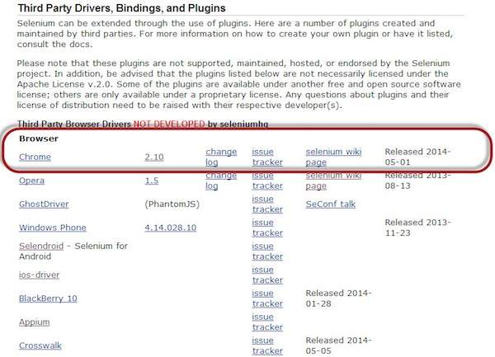

**Step 10** : Download the driver based on the type of your OS. We will execute it on Windows environment, hence we will download the Windows Chrome Driver. After you have downloaded, unzip the exe file and place it in a folder which has to be referred while launching chrome nodes.

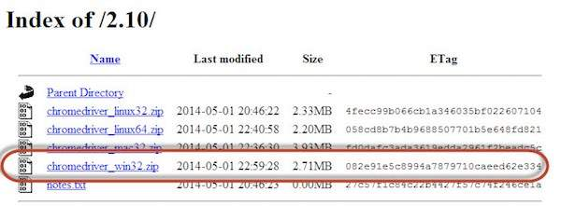

**Step 11** : Launch Chrome using the following command.

C:\>java -Dwebdriver.chrome.driver=D:\chromedriver.exe -jar D:\JAR\selenium-server-standalone-2.42.2.jar -role webdriver -hub http://10.30.217.157:4444/grid/register -browser browserName=chrome,platform=WINDOWS -port 5557

Where,

D:\chromedriver.exe = The location of the downloaded the chrome Driver(on the Node Machine)

D:\JAR\selenium-server-standalone-2.42.2.jar = Location of the Selenium Server Standalone Jar File(on the Node Machine)

http://10.30.217.157:4444 = IP Address of the Hub and 4444 is the port of the Hub

browserName = chrome (Parameter to specify the Browser name on Nodes)

5557 = Port on which chrome Node would be up and running.

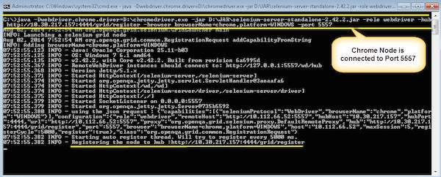

**Step 12** : After executing the command, come back to the Hub. Navigate to the URL - http://10.30.217.157:4444 and the Hub would now display the chrome node attached to it.

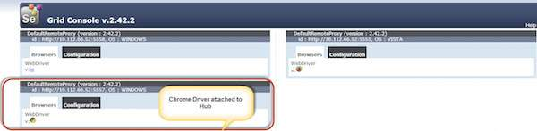

### Develop the Script and Prepare the XML File

**Step 1** : We will develop a test using TestNG. In the following example, we will launch each one of those browsers using remote webDriver. It can pass on their capabilities to the driver so that the driver has all information to execute on Nodes.

The Browser Parameter would be passed from the "XML" file.

package TestNG;

import org.openqa.selenium.*;

import org.openqa.selenium.remote.RemoteWebDriver;

import org.openqa.selenium.remote.DesiredCapabilities;

import org.testng.annotations.AfterTest;

import org.testng.annotations.BeforeTest;

import org.testng.annotations.Parameters;

import org.testng.annotations.Test;

import java.net.URL;

import java.util.concurrent.TimeUnit;

import java.net.MalformedURLException;

public class TestNGClass

{

public WebDriver driver;

public String URL, Node;

protected ThreadLocal<RemoteWebDriver> threadDriver = null;

@Parameters("browser")

@BeforeTest

public void launchapp(String browser) throws MalformedURLException

{

String URL = "http://www.calculator.net";

if (browser.equalsIgnoreCase("firefox"))

{

System.out.println(" Executing on FireFox");

String Node = "http://10.112.66.52:5555/wd/hub";

DesiredCapabilities cap = DesiredCapabilities.firefox();

cap.setBrowserName("firefox");

driver = new RemoteWebDriver(new URL(Node), cap);

// Puts an Implicit wait, Will wait for 10 seconds before throwing exception

driver.manage().timeouts().implicitlyWait(10, TimeUnit.SECONDS);

// Launch website

driver.navigate().to(URL);

driver.manage().window().maximize();

}

else if (browser.equalsIgnoreCase("chrome"))

{

System.out.println(" Executing on CHROME");

DesiredCapabilities cap = DesiredCapabilities.chrome();

cap.setBrowserName("chrome");

String Node = "http://10.112.66.52:5557/wd/hub";

driver = new RemoteWebDriver(new URL(Node), cap);

driver.manage().timeouts().implicitlyWait(10, TimeUnit.SECONDS);

// Launch website

driver.navigate().to(URL);

driver.manage().window().maximize();

}

else if (browser.equalsIgnoreCase("ie"))

{

System.out.println(" Executing on IE");

DesiredCapabilities cap = DesiredCapabilities.chrome();

cap.setBrowserName("ie");

String Node = "http://10.112.66.52:5558/wd/hub";

driver = new RemoteWebDriver(new URL(Node), cap);

driver.manage().timeouts().implicitlyWait(10, TimeUnit.SECONDS);

// Launch website

driver.navigate().to(URL);

driver.manage().window().maximize();

}

else

{

throw new IllegalArgumentException("The Browser Type is Undefined");

}

}

@Test

public void calculatepercent()

{

// Click on Math Calculators

driver.findElement(By.xpath(".//*[@id='menu']/div[3]/a")).click();

// Click on Percent Calculators

driver.findElement(By.xpath(".//*[@id='menu']/div[4]/div[3]/a")).click();

// Enter value 10 in the first number of the percent Calculator

driver.findElement(By.id("cpar1")).sendKeys("10");

// Enter value 50 in the second number of the percent Calculator

driver.findElement(By.id("cpar2")).sendKeys("50");

// Click Calculate Button driver.findElement(By.xpath(".//*[@id='content']/table/tbody/tr/td[2]/input")).click();

// Get the Result Text based on its xpath

String result = driver.findElement(By.xpath(".//*[@id='content']/p[2]/span/font/b")).getText();

// Print a Log In message to the screen

System.out.println(" The Result is " + result);

if(result.equals("5"))

{

System.out.println(" The Result is Pass");

}

else

{

System.out.println(" The Result is Fail");

}

}

@AfterTest

public void closeBrowser()

{

driver.quit();

}

}

**Step 2** : The Browser parameter will be passed using XML. Create an XML under the project folder.

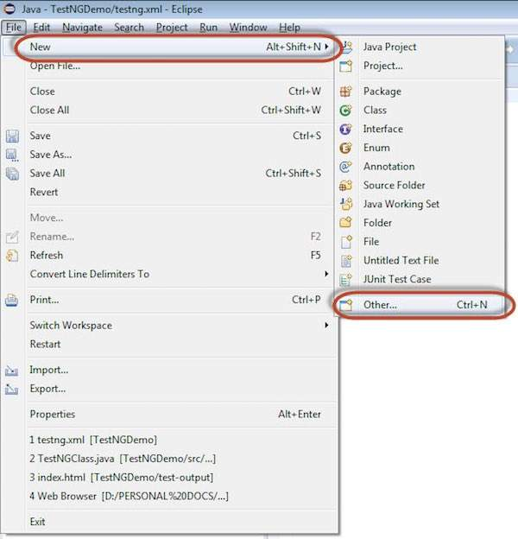

**Step 3** : Select 'File' from 'General' and click 'Next'.

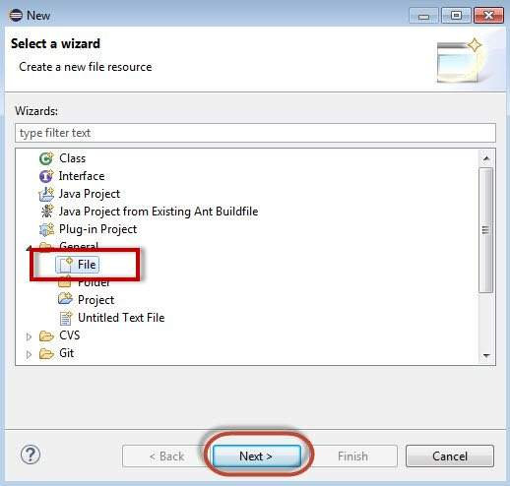

**Step 4** : Enter the name of the file and click 'Finish'.

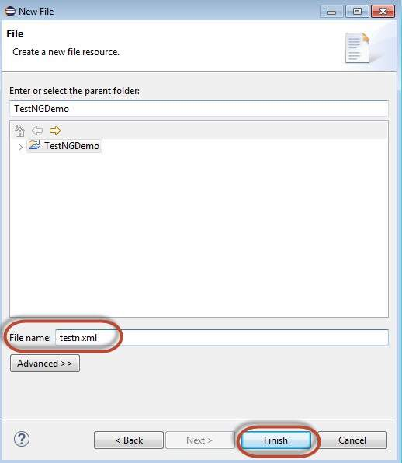

**Step 5** : TestNg.XML is created under the project folder as shown below.

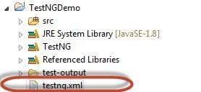

**Step 6** : The contents of the XML file are shown below. We create 3 tests and put them in a suite and mention parallel="tests" so that all the tests would be executed in parallel.

<?xml version="1.0" encoding="UTF-8"?>

<!DOCTYPE suite SYSTEM "http://testng.org/testng-1.0.dtd">

<suite name="Suite" parallel="tests">

<test name="FirefoxTest">

<parameter name="browser" value="firefox" />

<classes>

<class name="TestNG.TestNGClass" />

</classes>

</test>

<test name="ChromeTest">

<parameter name="browser" value="chrome" />

<classes>

<class name="TestNG.TestNGClass" />

</classes>

</test>

<test name="IETest">

<parameter name="browser" value="ie" />

<classes>

<class name="TestNG.TestNGClass" />

</classes>

</test>

</suite>

### Test Execution

**Step 1** : Select the created XML; right-click and choose 'Run As' >> 'TestNG Suite'.

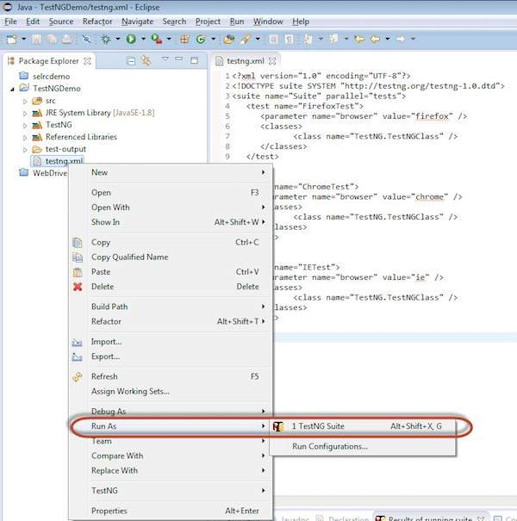

**Step 2** : Now open the Node, where we have launched all the browser nodes. You will see all the three browsers in execution simultaneously.

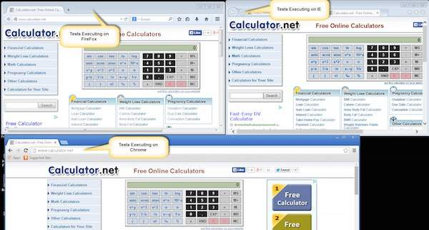

### Result Analysis

**Step 1** : Upon completing the execution, we can analyze the result like any other execution. The result summary is printed in the console as shown in the following snapshot.

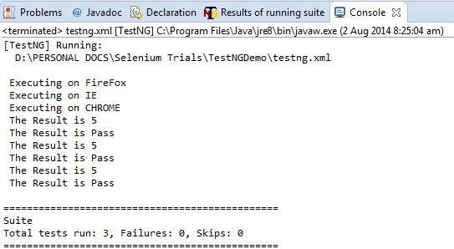

**Step 2** : Navigate to the 'Results of Running Suite' Tab and TestNG would display the result summary as shown below.

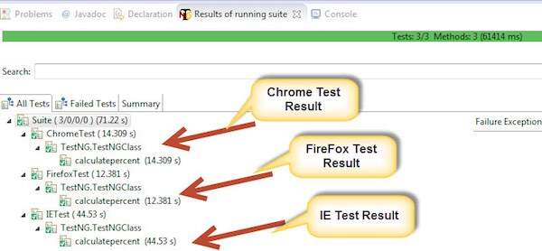

**Step 3** : Upon generating the HTML, we will be able to see the test results in HTML format.

